**S.P. Mandali’s**

**Ramnarain Ruia Autonomous College**

**Matunga, Mumbai-400019**

**Department of Computer Science Information Technology**

**Project Report**

**on**

**TOMATO LEAF DISEASE DETECTION SYSTEM USING**

**CNN**

**Project Guide**

**Mr. MAHAVIR ADVAYA**

**Project By**

**BODKE SAHIL SANTOSH**

MSC Information Technology

**2023-24**

**ACKNOWLEDGEMENT**

I would like to express my sincere gratitude to the Course Co-Ordinator,

**Mr. Mahavir Advaya** for giving me the opportunity to work on this topic. It would never be possible for me to take this project to this level without his innovative ideas, relentless support and encouragement.

The success and outcome of this project required a lot of guidance and assistance from many people and I am extremely privileged to have got this all along with the completion of the project. I would like to appreciate the effort of all my classmates who assisted me whenever I needed some sort of help in various aspects of the project development, to all of you, I say thank you. It helped me increase my knowledge and skills. I will forever be grateful.

**INDEX**

|  |  |  |
| --- | --- | --- |
| **SR. NO.** | **PARTICULARS** |  |
| 1 | Abstract   * Problem statement |  |
| 2 | Introduction   * Detailed explanation of study area |  |
| 3 | Literature Review  ● Study undertaken on similar concept |  |
| 4 | Research Methodology  ● Description of Algorithms / procedures / data collection methods   * Process flow |  |
| 5 | Experimental setup   * Tools * Architecture/Framework * Software Language |  |
| 6 | Results   * Screen Layout * Code * Testing report |  |
| 7 | Conclusion   * Future enhancements |  |
| 8 | References   * References (Conference Papers/ Journal Papers etc.) |  |

**Table of Contents**

ABSTRACT 5

1.1 Problem Statement: 6

INTRODUCTION 7

LITERATURE REVIEW 8

3.1 Study undertaken on similar concepts: 9

RESEARCH METHODOLOGY 10

4.1 Description of Algorithms: 10

4.1.1 Data collection Method / Procedure: 17

4.2 Process Flow: 21

EXPERIMENTAL SETUP 23

5.1 Tools: 23

5.2 Architecture/Framework: 23

5.3 Software Languages: 23

5.4 Model Deployment: 23

RESULTS 24

6.1 Screen Layout: 24

6.2 Code: 24

6.3 Test Reports: 32

CONCLUSION 34

7.1 Future Enhancements: 34

REFERENCES 35

**ABSTRACT**

The global rise in population has led to a shortage of raw materials and food supplies. Tomato is the most popular crop in the world and in every kitchen, it is found in different forms irrespective of the cuisine. After potato and sweet potato, it is the crop which is cultivated worldwide. India ranked 2 in the production of tomato. However, the quality and quantity of tomato crop goes down due to the various kinds of diseases. If farmers can identify these diseases early and treat them appropriately, they can save a lot of money. So, to detect the disease a deep learning-based approach is discussed in the article. Leaf conditions can help identify various illnesses in tomato plants. In this project, with the help of convolution neural network we tried to classify a tomato plant by its leaf whether it is healthy or not. Mainly there are three classes Late Blight, Early Blight and Healthy. According to the confidence each tomato leaf has been classified. A simple CNN architecture is used to train and test the model. Main objective was to create a web api which will take leaf image as input and will classify according to the trained model. In this model, there are 3 convolution and 3 max pooling layers followed by 2 fully connected layer. The experimental result shows the efficacy of the proposed model over pre-trained model. The classification accuracy varies from 85.27% to 97.32% with respect to classes and average accuracy of the proposed model is 97% for the 3 classes.

* 1. **Problem Statement.**

Farmers who grow tomato are facing lot of economic loss every year because of various diseases that can happen to tomato plant

There are two common diseases known as:

1. Early blight – which is caused by fungus.
2. Late blight – which is caused by specific micro-organism.

Ans if farmers can detect this diseases early they can apply appropriate treatment then it can save lot of waste and prevent the economic loss. The treatment for early blight and late blight are different so its most important that you accurately identify what kind of diseases is there in that tomato plant

Data augmentation because we might not have enough diverse set of images so we need to rotate and flip adjust contrast to create more training samples. Once we have that will use model building using CNN it is standard way of doing image classification as of 2021 Therefore we are using CNN and then export the train model onto our disk. We have covered some Mlops concepts using TF where we will have TF serving server running on top of these exported models.and tf serving will call from FastAPI.

We have build wesite in ReactJS as it is hot technology as of today. And finally will deploy our project on GCP(Google Cloud Platform)

**INTRODUCTION**

Tomatoes are one of the world's most widely farmed and consumed vegetables, providing important nutrients and taste in a variety of meals. Tomato farming has significant effects beyond the culinary arena, affecting worldwide agriculture and economics. However, the tomato plant is always facing a variety of diseases that affect crop productivity, quality, and food security. It is essential for farmers to be able to diagnose and control these illnesses quickly in order to assure sustainable tomato farming techniques and fulfill the increasing worldwide demand for this versatile fruit. Traditional disease detection methods, which rely on observation by farmers and agricultural professionals, are truly subjective and prone to human error. Also, these procedures frequently result in late-stage illness identification, lowering treatment efficacy and increasing the danger of yield losses. In response to these issues, our project aims to use cutting-edge technology and machine learning to develop a solution that extends beyond the constraints of traditional illness detection approaches. We aim to construct an automated disease detection system by studying the various visual symptoms shown in tomato leaves when infected with diseases. This project's major purpose is to develop a comprehensive and dependable tool for early detection and correct classification of tomato leaf diseases. We intend to provide tomato farmers and agricultural professionals with a tool capable of identifying common diseases such as Early Blight, Late Blight, Healthy by leveraging machine learning algorithms, image processing techniques, and a large dataset of tomato leaf images. This project explores into the techniques, findings, and effects of the Tomato Leaf Disease Detection project, building the path for a future in which technology and agriculture work in collaboration to protect the world's tomato crop yields.

**LITERATURE REVIEW**

Machine learning algorithms are applied in various fields, but feature engineering remains the main problem. This section provides a various deep learning technique used by researchers in plant disease identification. To train classify plant diseases that were not seen before. Model accuracy was substantially reduced while testing image conditions are different than training image. Sometimes, disease appears on upper sides of the leaves sometime, lower sides of the leaves. trained both and VGG16net with minimum batch size, weight and bias learning rate as hyper-parameters. Accuracy is negatively correlated with minimum batch size in case of VGG16net. Convolution and pooling layers together stacked in a module and applied to GoogleNet architecture as Inception V4 for dimension reduction applied weights that are pre-trained on ImageNet to this architecture average pooling layer of 8 × 8 for fine tuning. In addition to that DenseNets with 122 layers is also fined tuned for plant disease recognition. Performance of various CNN for plant disease identification depends on various factors: availability of limited number of annotated; poor representation of disease symptoms, image background and capturing conditions; limited variations in disease symptoms.

**3.1 Study undertaken on Similar concepts.**

There are been numerous studies and projects related to image classification

And deep learning in the field of computer vision. Many of these studies share

Similar concept and techniques.

* ImageNet Classification:

The ImageNet Large Scale Visual Recognition Challenge is a famous competition in which participants develop models for classifying images into thousands of categories. Many studies and projects have been based on similar principles, using deep learning models, large-scale image datasets, and techniques like transfer learning.

* Fine-Grained Classification:

Fine-grained image classification tasks involve distinguishing between visually similar categories. For example, identifying different species of birds or types of flowers. These tasks require specialized techniques and models to handle subtle visual differences.

* Medical Image Analysis:

The field of medical image analysis has seen extensive use of deep learning for tasks like diagnosing diseases from medical images (e.g., X-rays, MRIs, CT scans). Similar principles of image classification are applied in these projects

* Artwork Recognition:

Some projects involve classifying artwork, distinguishing between different artists, styles, or art movements. This is another application of image classification, often involving deep learning models.

**RESEARCH METHODOLOGY**

**4.1 Description of Algorithms.**

**What is Convolution Neural Networks** ?

Convolutional Neural Networks are a special type of Neural Networks that has shown to be extremely effective in image categorization. As they provide extra layers such as convolution, pooling these networks can be used in computer vision applications and they are very useful in face recognition, object detection.

Generally, this special type of networks consists of more than one convolutional layer. In the end layers they are followed by dense layers which are fully connected such as a simple neural network. CNN is made in such a way it takes the advantage of Two-dimensional structure of an image. In this, tied weights and local connections has been used. Then they are followed by max or mean pooling layers which are used to extract the most prominent features. Main advantage CNNs have over normal neural networks are that instead of having same number of hidden layers, they will have less parameters to train as compared to neural networks. They are easier to train because of having less parameters.

Overview of Different Operations in CNN:



As shown in figure above, it is a CNN architecture which contains some sequential operations. This simple CNN consists of convolutional layer in which a kernel or filter is applied which is used to detect the vertical or horizontal edges and then it is followed by Relu activation function. Next layer is max pooling layer in which a kernel is applied to extract the most prominent features from the image. Then followed by fully connected dense layers. Accuracy of the model is determined by the loss function in forward propagation and according to the loss value weights, filters and bias are updated in back propagation which may be through gradient descent or AdaDelta or adam.

**Convolution**

In this operation, a small tensor is applied across an input image which is called as a kernel or a filter. Its main task is to extract the important features from the image. After this operation a feature map is generated which is computed through element wise multiplication of each value in image and kernel. This feature map will contain the vertical and horizontal edges which are enhanced in next step.

**Figure showing convolution operation**





Above figure is showing a convolution operation on a 5x5 image. Filter size is 3x3 without padding and stride equal to 1. If there is no padding then it will reduce its size as shown in the figure. To maintain same image size padding is used which will add extra pixels across image to maintain its size.

**Formula to calculate image size:**

**(N+ 2P – F)/S + 1**

Where N = image size

P = padding

F = kernel size

S = stride

**Figure with padding:**



**Activation Function:**

Feature maps which are obtained after applying convolution are passed through an activation function. These activation functions are non-linear to introduce non-linearity in the network. Activation functions such as sigmoid, tangent are not used in hidden layers as it may result is vanishing gradient problem. Highly used activation function is Relu function.

F(x) = max(0,x)



**Pooling Layer**

This layer is used to extract the most important features. Its main task is to reduce the learnable parameters. It reduces the height and width of feature map but depth remains same.

**Max Pooling**

In this layer a kernel is applied across an image which will extract maximum value from each patch. Mainly 2x2 filter size is used with stride equal to 2 over an image. Below is the figure showing max pooling operation.



**Fully Connected Dense Layer**

After receiving feature maps from max pooling layer, these feature maps are flattened and passed to a fully connected dense layer. Feature maps are first converted to a one-dimensional array and passed to a dense layer. There can be many dense layers in-between. Final output layer mainly contains the number of output classes. Every hidden dense layer contains an activation function. Most commonly used activation function is Relu.

**Activation Function at Last Layer**

Activation function which is used at last output layer is different from the activation functions that has been used in hidden dense layers as their main task is to introduce non-linearity. Activation function at last layer is used to categorize that means it gives probability of each class. If there are two classes then sigmoid function is used. But in this project, there are more than two categories. So, in this situation softmax function is used which will normalize in such a way that each probability value lies in range of 0-1 and final sum will be 1. Below is the figure showing output of a sigmoid function.



In forward propagation all the weights, filters and bias are calculated. These are then validated by a cost function which will give error. Error is the difference between actual label and predicted label. In back propagation weights, filters and bias updation occurs. This updation is carried out by an optimizer which is an algorithm. Its task is to find values of weights, filters and bias is such a way that it will reduce its loss. There are many optimizers available. One which I am using is adam.

**Loss Function**

Loss function is used to validate our result. It gives the difference between actual label and predicted label. When records are passed in batches or all the records are passed then loss function is termed as cost function. There are many types of cost functions such as multi-class cross entropy and sparse categorical cross entropy. Different loss functions may give different results. So, we need to choose loss functions according to the use case.

**Optimizers**

Optimizers are algorithms which are used to minimize the loss by updating weights and bias. Optimizers are of different types. The optimizer which we are using is referred to as adam optimizer.

**Adam Optimizer**

Adam optimizer is state of the art algorithm. It increases the speed of gradient descent. It is very effective when using a data set which is very large in size. It uses both momentum concept i.e., exponential weighted average as well as dynamically changing learning rate. It is very fast and resource effective. It is a combination of both gradient descent with momentum and Root mean squared propagation.

* + 1. **Data Collection Method / Procedure.**

**Data Set Used in the Major Project**

Any supervised machine learning project starts with data collection process

There are basically three steps to collect dataset:

1) Collect and annotate data on your own.

2) Write web scrapping scripts to collect images from internet.

3) Buy data from third party vendors or use public repositories such as Kaggle.

Dataset is taken from Kaggle repository. Dataset consist of images belonging to three different classes. Below is the link for dataset:

https://www.kaggle.com/arjuntejaswi/plant-village

Dataset contains three types of images:

  

Tomato_Healthy Tomato_Early_Blight Tomato_Late_Blight

First of all importing all libraries



Specifying batch size in which each image will be processed. Image size is 256x256. Image is in RGB format. So, there are 3 channels. Epochs specify that how many times forward and back propagation will occur.

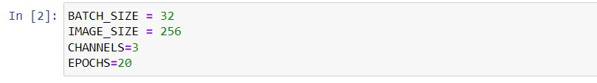

We will use keras to create an input pipeline. In which we have to specify the directory in which images are there. There are three different folders separated according to their classes. Folder name will be considered as the class of each image present in that folder. As all of the images are of (256x256). So, image size is 256. We also need to specify batch size and it will process the images in batches. Benefit of processing in batches will be that it will utilize the resources effectively. If there is a huge dataset that is greater in size as compare to ram of the system then system may crash.

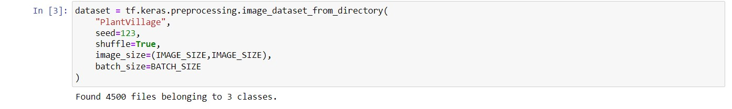

There are Three classes as shown below

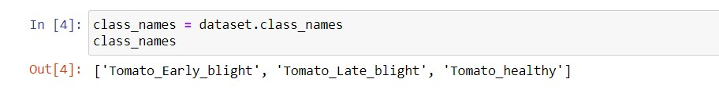

As shown below, each element in the dataset is a tuple. First element is a batch of 32 elements of images. Second element is a batch of 32 elements of class labels.



Our dataset looks balanced now. We can create a model on top of this data.

Plotting the images with their class label using matplotlib

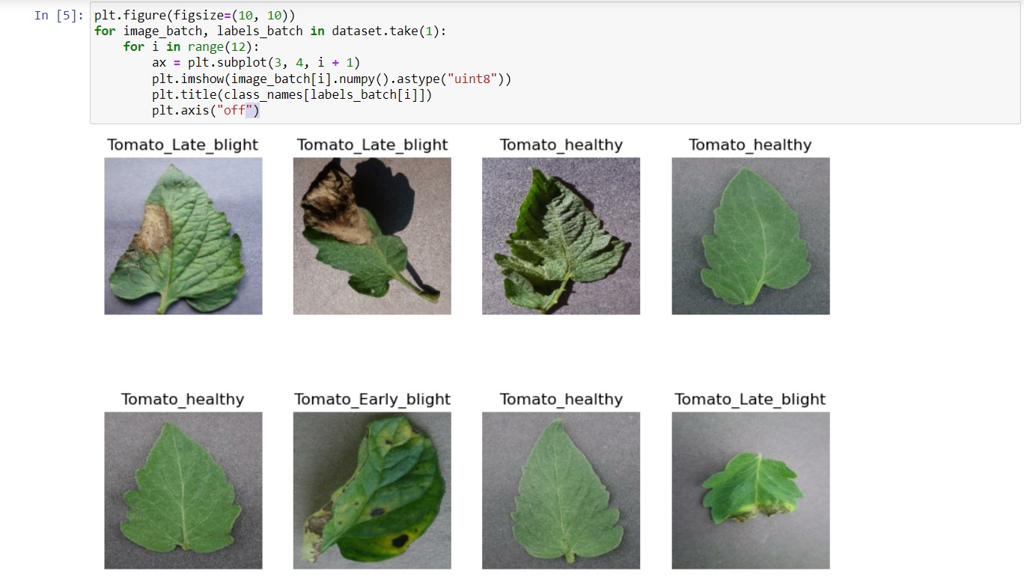

For splitting the data into training, testing and validation set a function is defined which takes dataset as an input. Other parameters have default values for train, validation and test split. There is also a shuffle parameter which will shuffle the images in the dataset to add randomness.

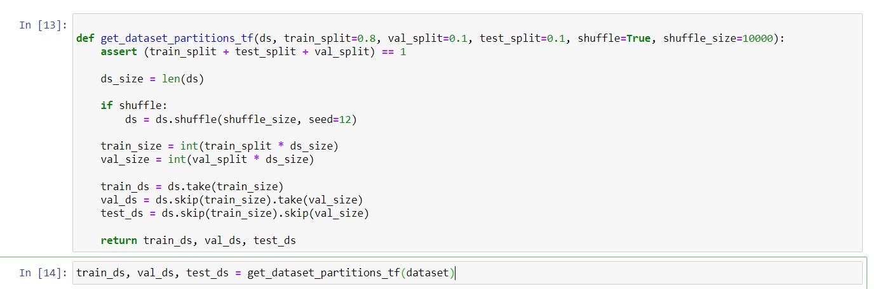

For resizing the input image if it is not of size (256x256) a layer has been defined using keras which will resize the image to (256x256) so that training can be done. It will also rescale the RGB values.

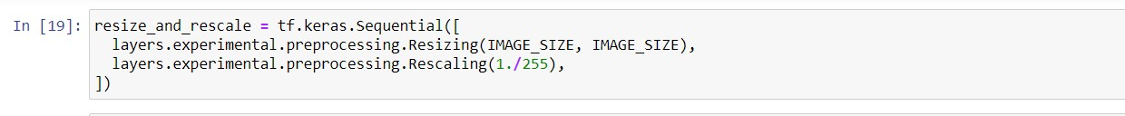

To reduce the chances of underfitting data augmentation has been done which will increase data. It will flip the pictures vertically or horizontally and will also change their contrast so that new input images could be created.



* 1. **Process Flow**

**State Transition Diagram of the Major Project**

State of the data changes every time it passes through a model. First, step is data pre-processing. Then data is splitted into two sets training set and test set. Training set is used for model building and training. Test set is used for model testing and checking the accuracy. Training set is further divided into a set which will be used for actual training and a validation set which is used for validation at back propagation. After model training, accuracy of the model is validated by using it on testing set. Then model is saved and deployed over an application.



After collecting the data, first step is data cleaning and pre-processing for which I am using tf dataset and data augmentation. Data augmentation used when dataset is not that large then we can just rotate or increase decrease the contrast of the image to create a new image which can be used as an input. Next step is model building using convolutional neural network. CNN is a standard way for image classification as it provides better accuracy as compare to normal neural network. Then saving the model for deployment. We have covered some ML ops concept using TF-servingwhere we can run server on top of exported models and it will call from FastApi.Then we will build a website in ReactJS as it hot technology for making website app development. Then backend of the web application is designed by FastApi Below is the figure showing state transition diagram.

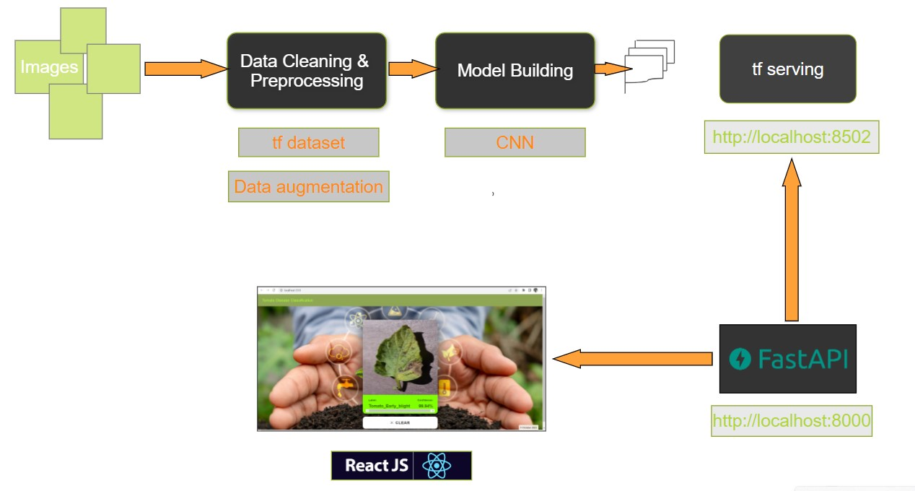

**EXPERIMENTAL SETUP**

**5.1 Tools**

* Jupyter notebook
* Visual Studio Code
* Postman
* Py-Charm Community
* Docker

**5.2 Architecture/Framework**

* Fast API
* React js

**5.3 Software Languages**

* Python
* HTML/CSS
* JavaScript

**5.4 Model Deployment**

* GCP (Google Cloud Platform)

**RESULT**

**6.1 Screen Layout**

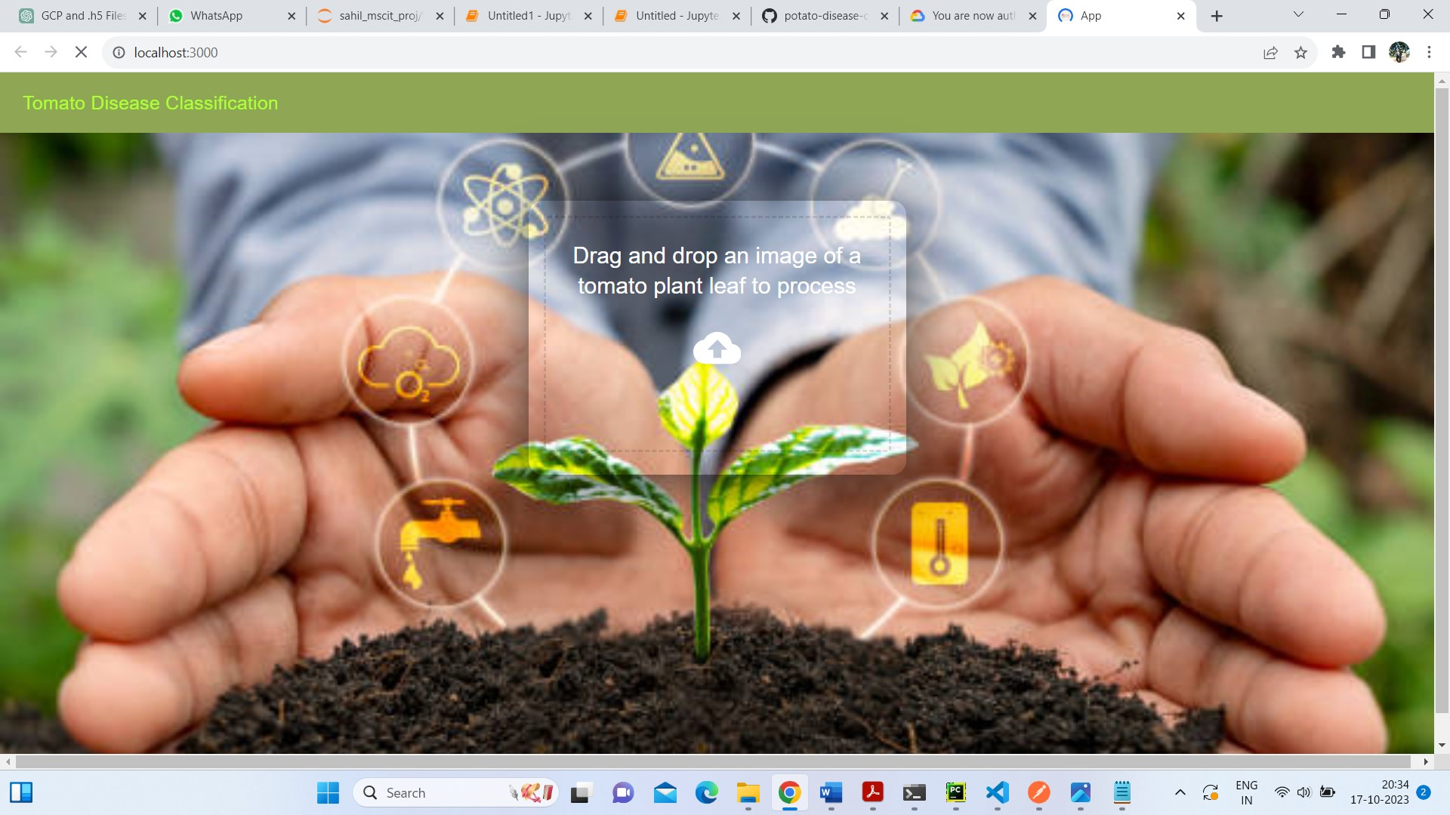

**6.2 Code**

After the data preprocessing steps, we trained a simple convolutional neural network. It contains a resizing and rescaling layer followed by number of convolution and max pooling layers. After these layers a fully connected layer is there with 64 neurons. At the end, there is output layer having three neurons as there are three different classes. In every hidden layer Relu activation function has been used. In output layer softmax function has been used. Below is the code:

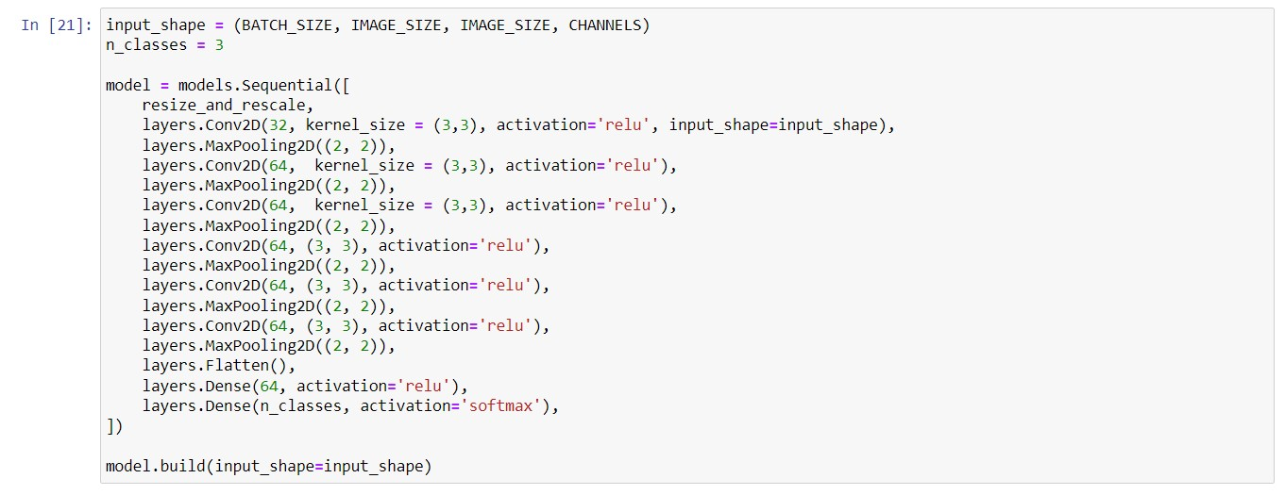

Detailed model architecture is shown below:

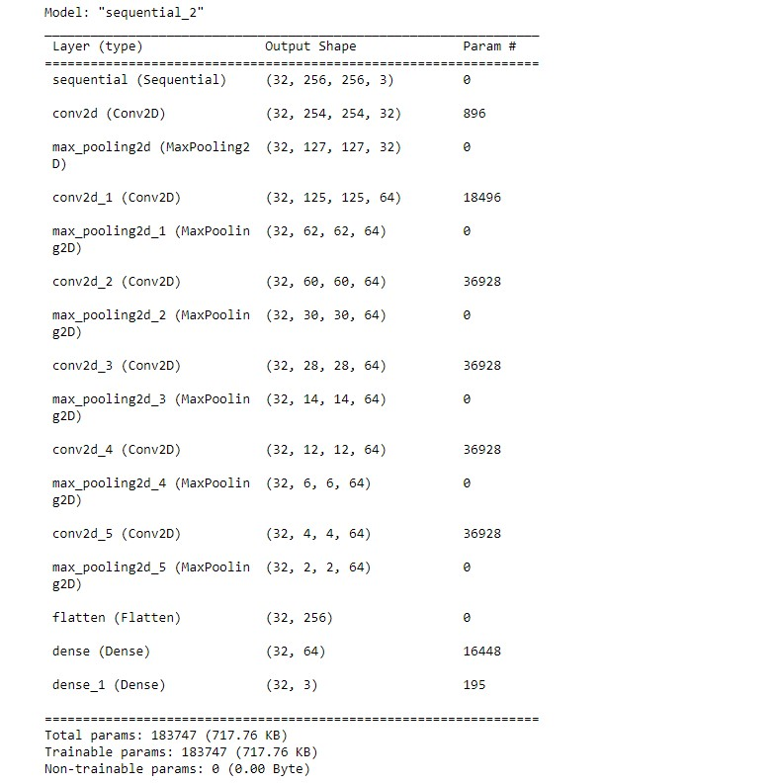

Total trainable parameters is shown above in the figure.

There are different type of loss functions. In this project sparse categorical cross entropy loss function has been used. Adam optimizer has been used which will reduce the loss by updating weights and bias.

Accuracy metrics has been used for validating the loss in back propagation.

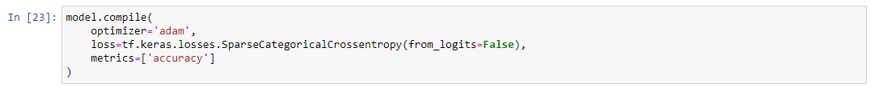

For plotting training and validation accuracy, value at each steps are stored in the variables. Below is the code.

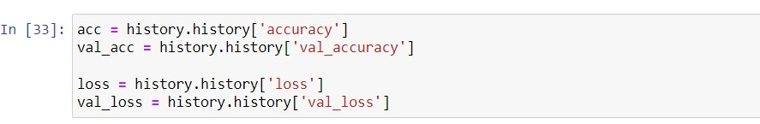

Below is the code and result of a graph between training accuracy vs validation accuracy and graph between training loss vs validation loss.

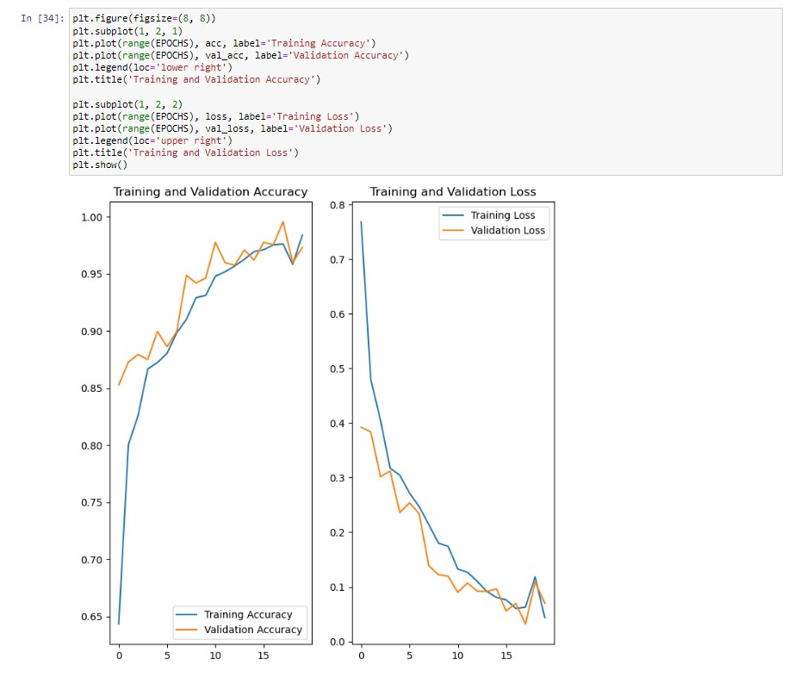

For prediction a function has been written which will take model and an input image as input parameters. Model will return an array which will contain the probability corresponding to each class from which we will select the probability having highest value. Below is the code:

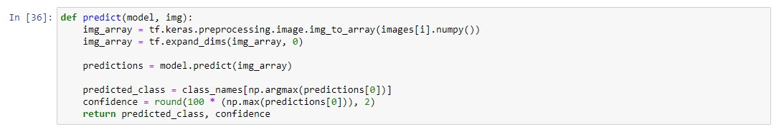

Predictions which we got after applying predict function are shown below:

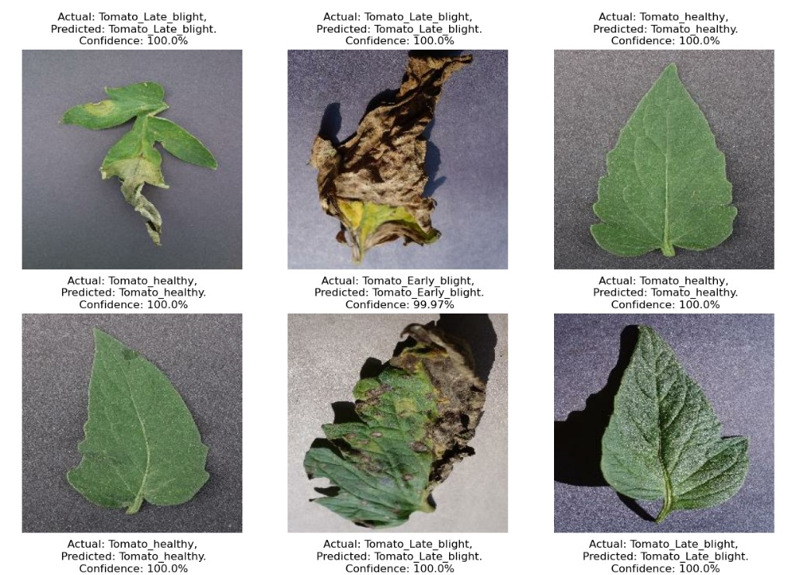

After that model was saved. So that it can be used for prediction in our web application.

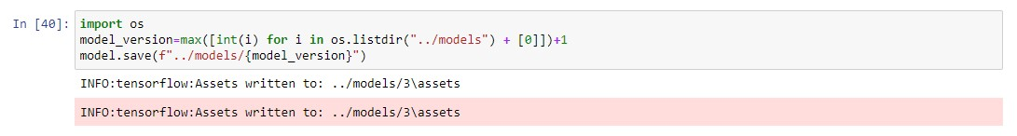

For creating the web application FastAPI has been used which will manage backend of the web applicaion. It is one of the emerging python framework which is used to create simple Rest APIs. Below is the implemented code:

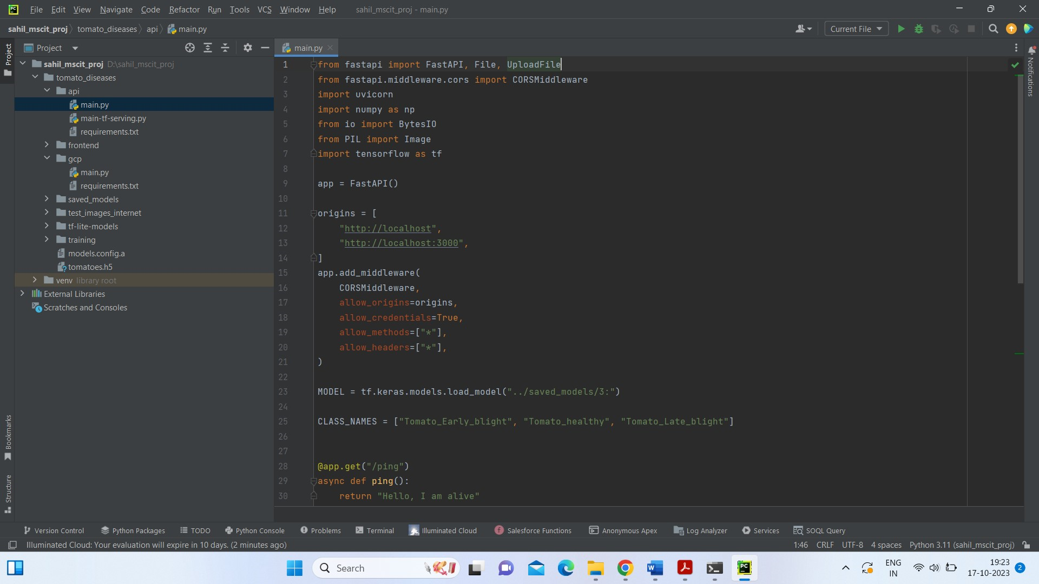

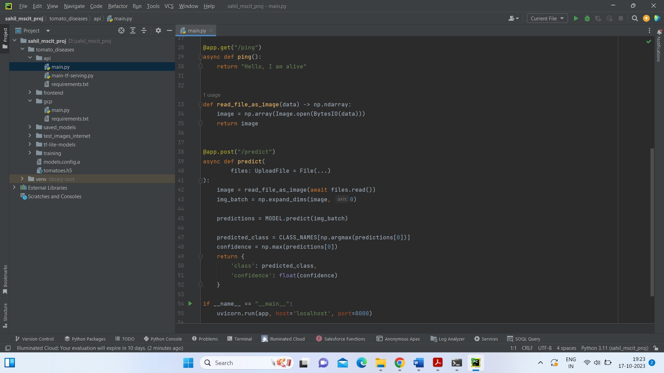

After running this code, web application will run at port 8000 we will check it with the help of postman in that will use POST method/ URL: http://localhost:8000/predict after that in form-data will provide image for classification, Here is the Output:

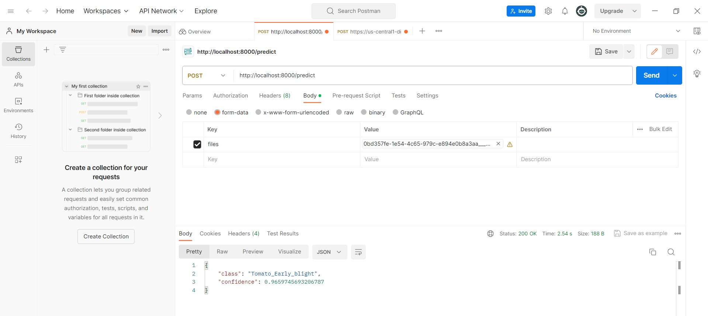

Given image has been classified as an Early_blight class with 0.96 confidence.

Now will create a website (Frontend part) where we will use reactjs in Vs Code and deploy our model and further part of deployment will show in Test reports.Here are some code snippets:

**App.js**

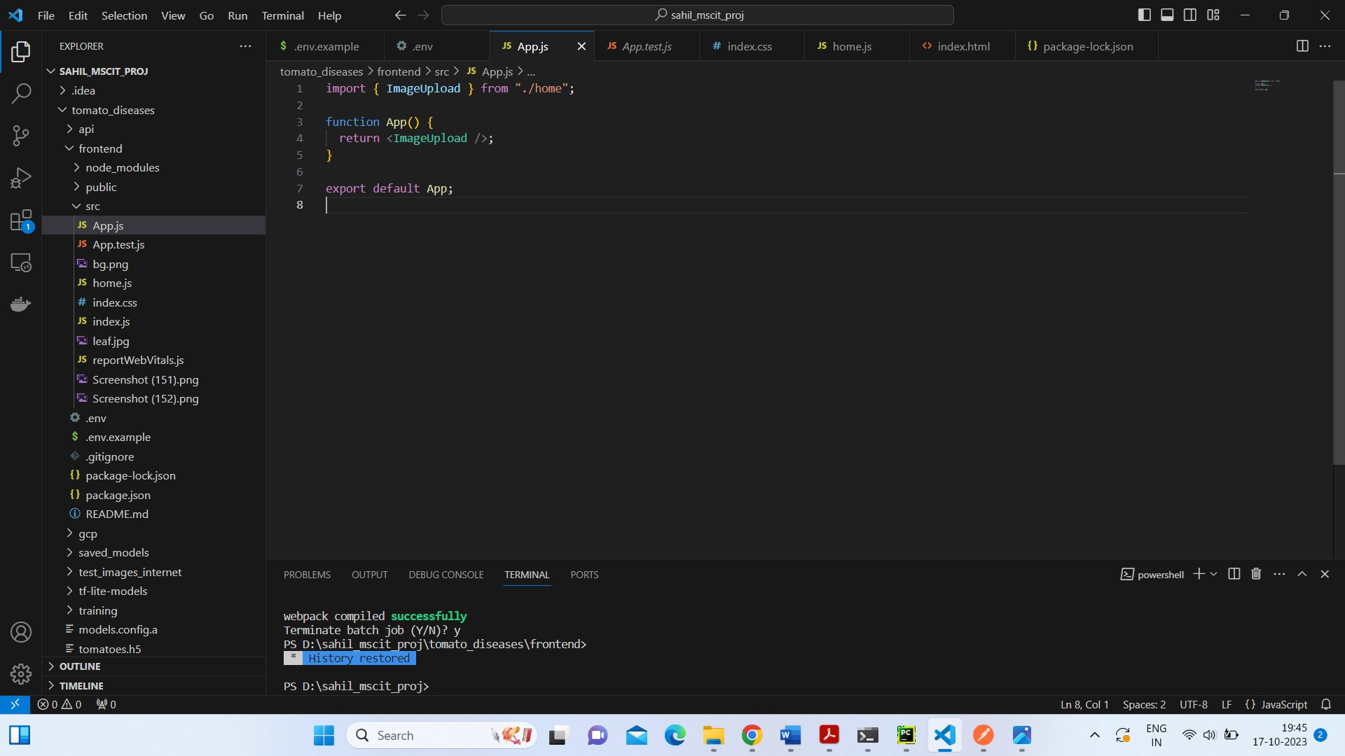

**Home.js**

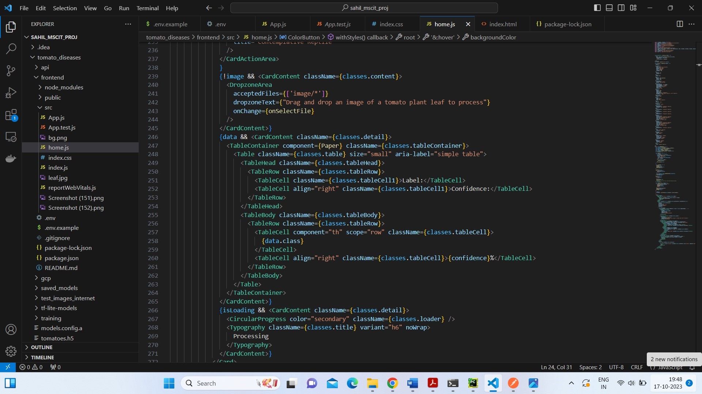

Once website is done we will deploy our model on Google Cloud Platform(GCP)

For that we have to write another code in jupyter notebook as we have to import new library ImageDataGenerator and have to follow same process as we done for developing website only final part we have to save models in .h5 format

An .h5 file is like a container for storing data, especially data related to machine learning models. On Google Cloud Platform (GCP), it's a place where you can put these .h5 files so that they can be easily used by your computer programs running in the cloud.

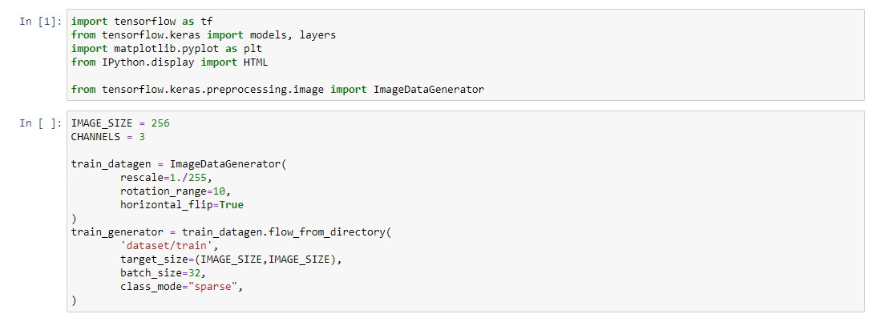

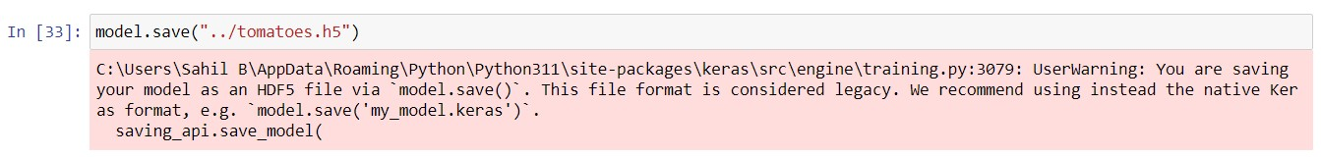

Now we will Create GCP account after that create project on GCP we have keep note of project_id while deploying then we will create GCP bucket in that we will upload path models/tomato-model.h5 then will install Google Cloud SDK.Here is cmd shown below:

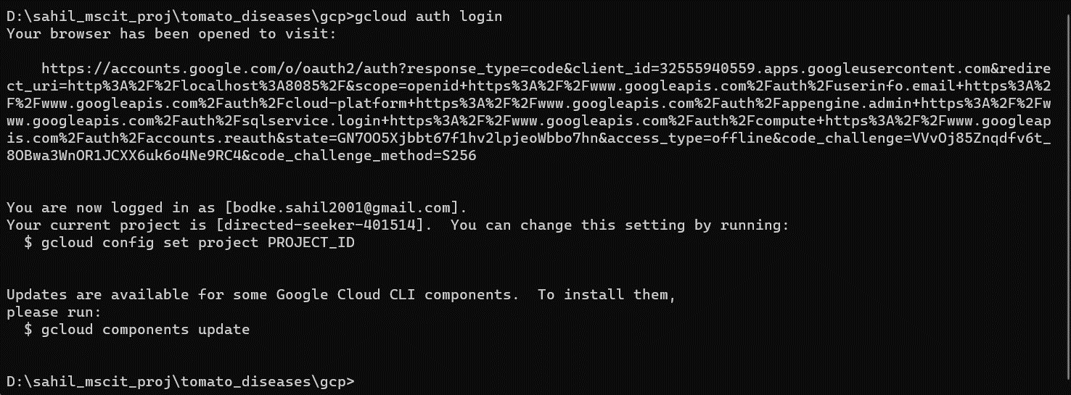

**6.3 Test Reports**

Here are test report of project this is development of website and deployment.

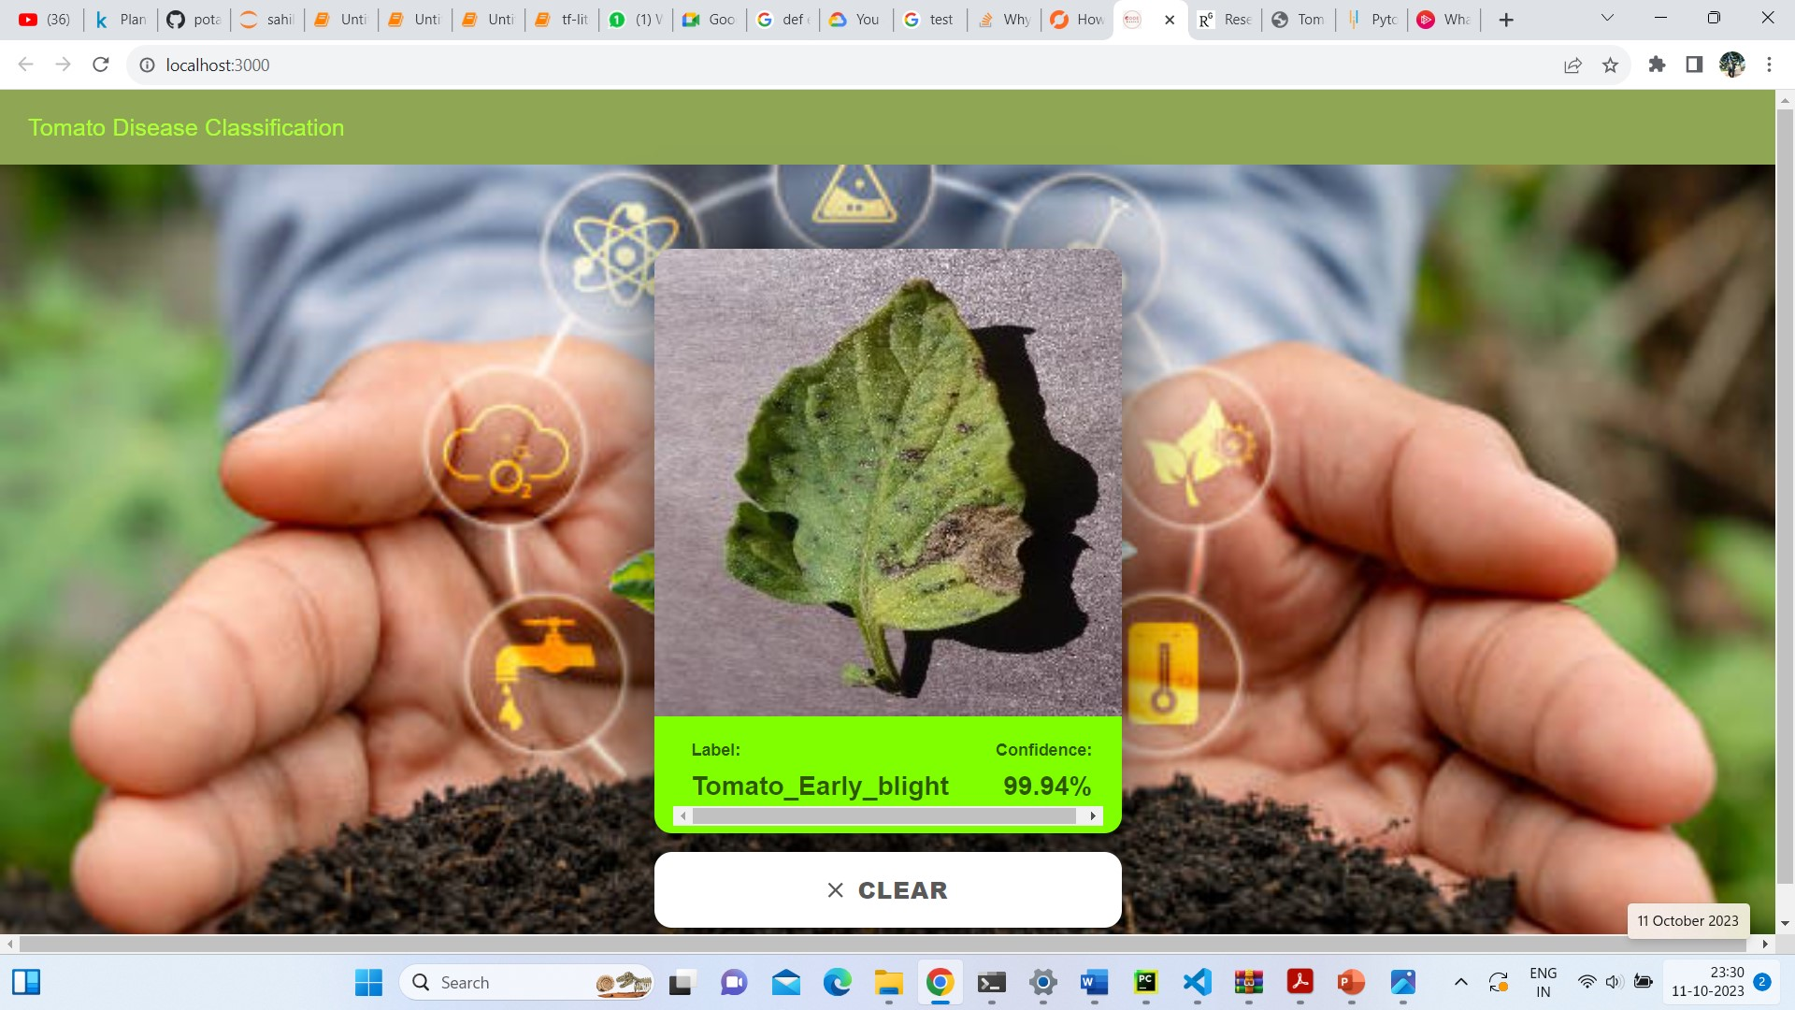

And Final Model development on Google cloud Platform (GCP) for that we have to write cmd in Google Cloud SDK shell to deploy our project.

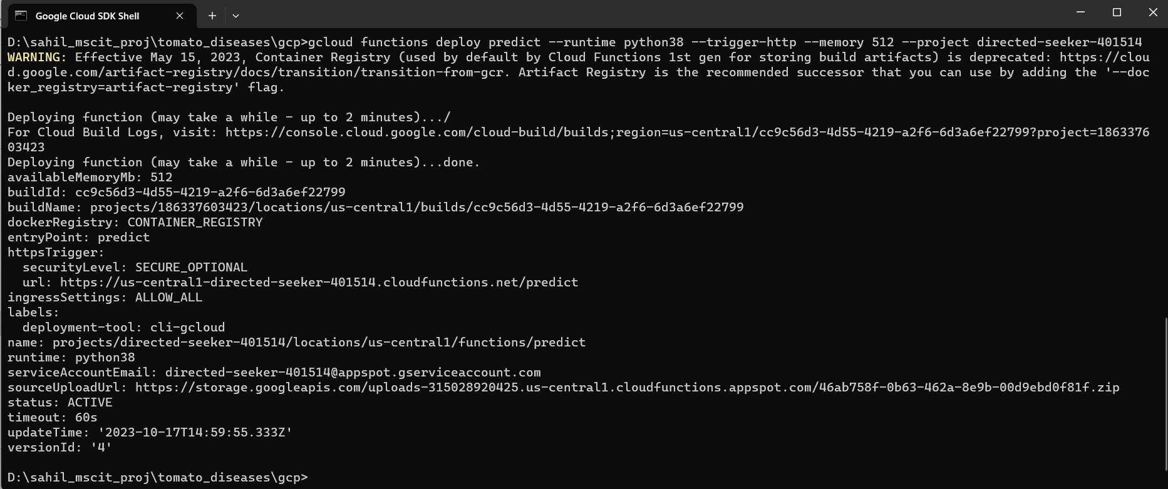

Here are Some test_images taken from google will predict it in Postman.

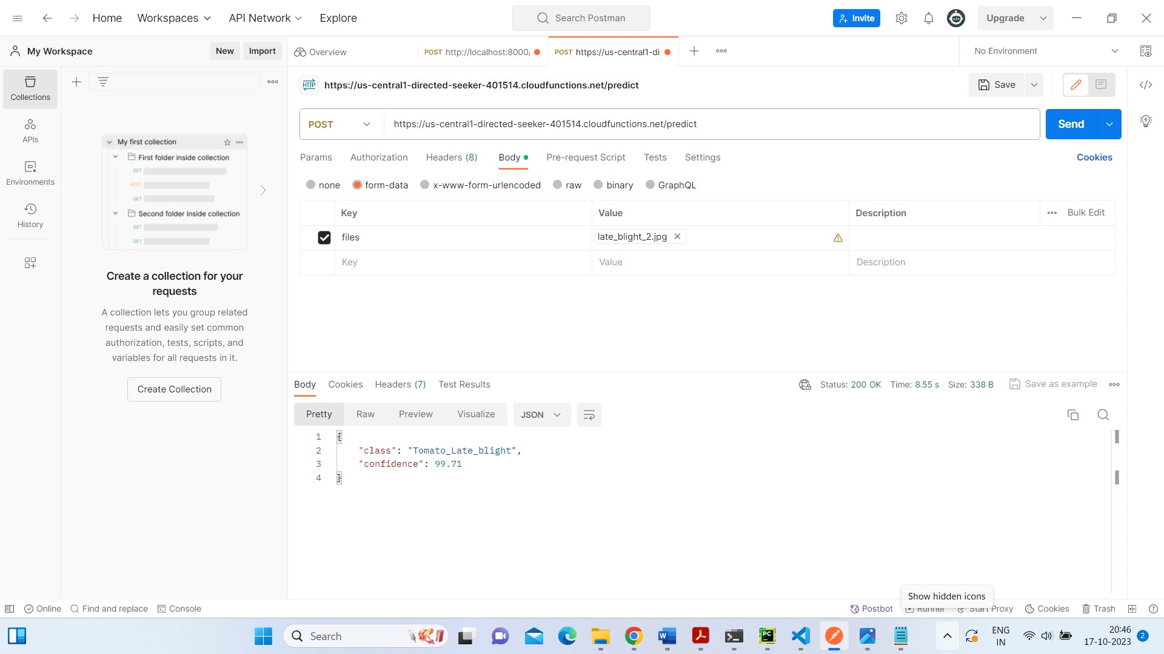

Given image has been classified as an Late_blight class with 99.71 confidence.

**CONCLUSION**

In this project, convolutional neural network architecture is used in the model. So, that it can be used to classify for web application. Image of a potato leaf will be given as an input then it will be able to classify whether plant is healthy or effected by late blight and early blight. With little modifications, this project can prove very beneficial for farmers. Without monitoring on our own, we can easily identify the plant is infected or healthy. It will reduce the production cost as well as preventive measures can be taken early. This project can be modified so that it can be used for disease identification for other species as well. This can be done in real time and in a better way by using computer vision.

**7.1 Future Enhancements**

To further improve the utility and impact of the project, future enhancements may include multi-class classification to identify different types of diseases and plant species, real-time monitoring capabilities for on-the-fly disease detection, and the development of a mobile application for instant feedback to farmers.

The integration of geospatial data and IoT sensors can enhance predictive capabilities, while crowdsourcing and collaboration with agricultural experts can lead to more robust and region-specific disease models.

To ensure continued success, the project should explore advanced data augmentation techniques, model interpretability, and the implementation of AutoML solutions. Furthermore, ongoing efforts to address security and privacy concerns, as well as scalability, are essential

**REFERENCES**

1. [**https://www.sciencedirect.com/science/article/pii/S1877050920306906**](https://www.sciencedirect.com/science/article/pii/S1877050920306906)
2. [**https://ieeexplore.ieee.org/document/8530532**](https://ieeexplore.ieee.org/document/8530532)
3. [**https://www.mdpi.com/2079-9292/12/1/229#:~:text=In%20%5B47%5D%2C%20the%20authors,obtaining%20an%20accuracy%20of%2096.55%25**](https://www.mdpi.com/2079-9292/12/1/229#:~:text=In%20%5B47%5D%2C%20the%20authors,obtaining%20an%20accuracy%20of%2096.55%25)**.**
4. [**https://www.researchgate.net/publication/355334796_Tomato_Leaf_Disease_Detection_Using_Hybrid_CNN-RNN_Model**](https://www.researchgate.net/publication/355334796_Tomato_Leaf_Disease_Detection_Using_Hybrid_CNN-RNN_Model)
5. [**https://www.irjmets.com/uploadedfiles/paper/issue_6_june_2022/26470/final/fin_irjmets1655734828.pdf**](https://www.irjmets.com/uploadedfiles/paper/issue_6_june_2022/26470/final/fin_irjmets1655734828.pdf)